TEAM ID: PNT2022TMID47004

IOT WATSON PLATFORM
Step1:loginin your registered
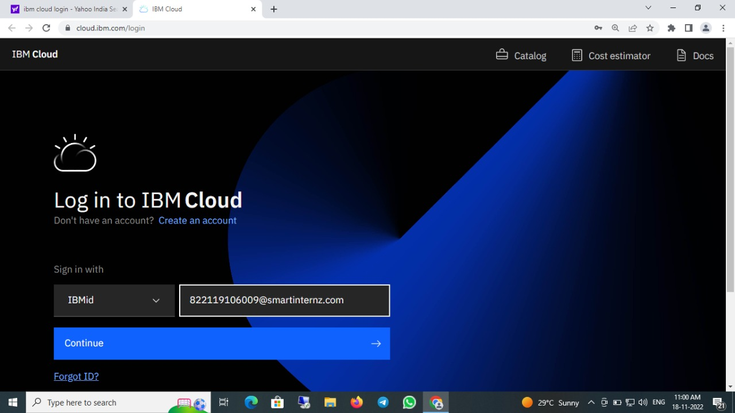

Step2:click catalog where you find the services and internet of thing you can select and make location as london
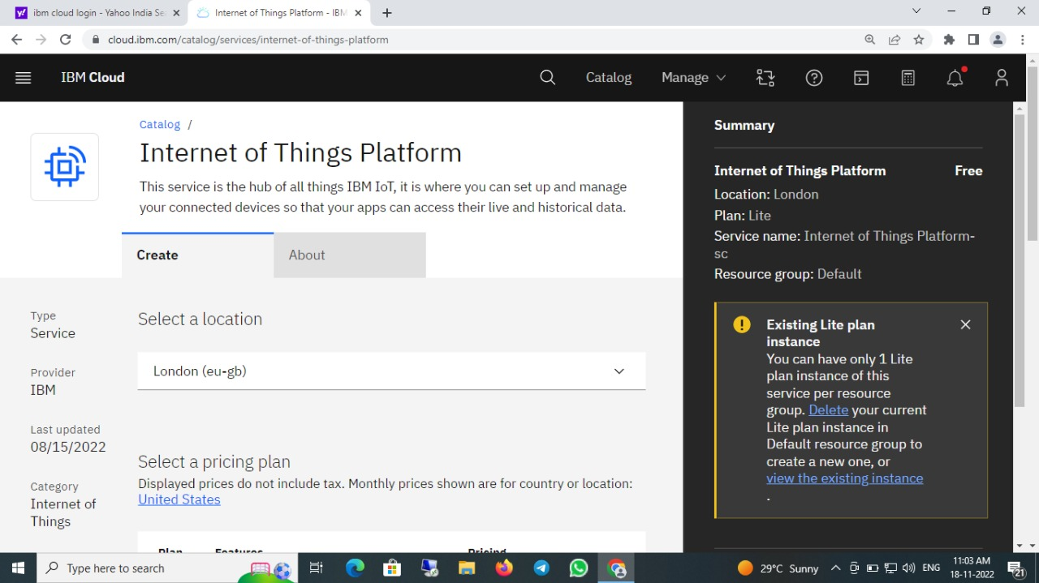
Step3: It redirect you to IBM WATSON platform where you need to click sign in

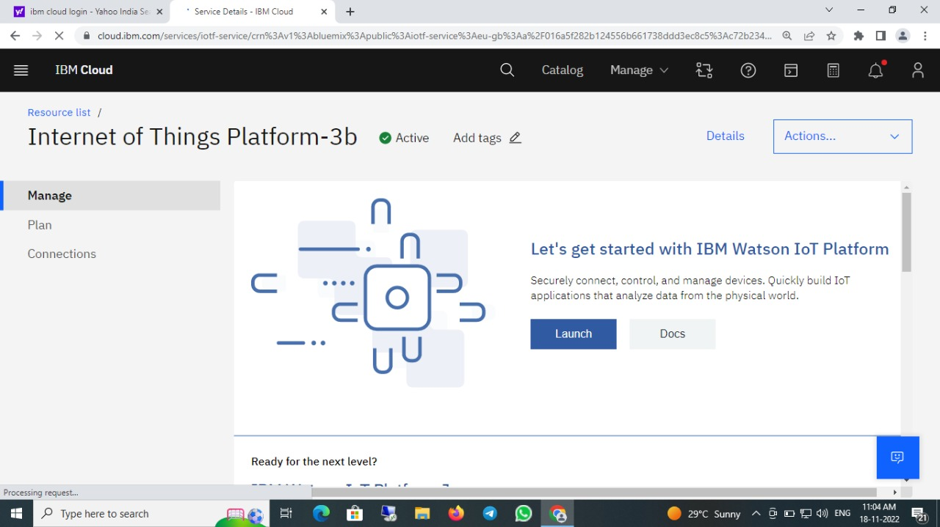
Step 4: It redirect you to IBM WATSON platform where you need to click sign in

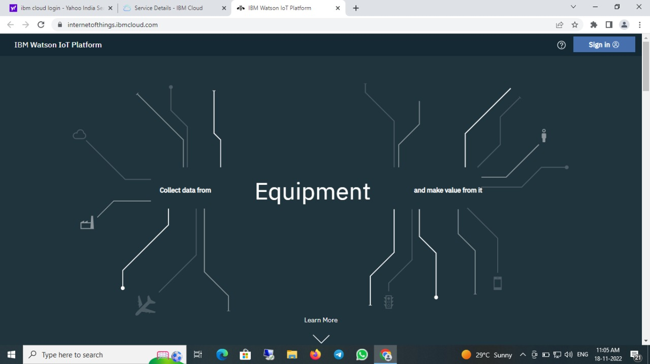
Step 5: where you find this tab which is used to add device ,app ,member ,usage ,security can be worked

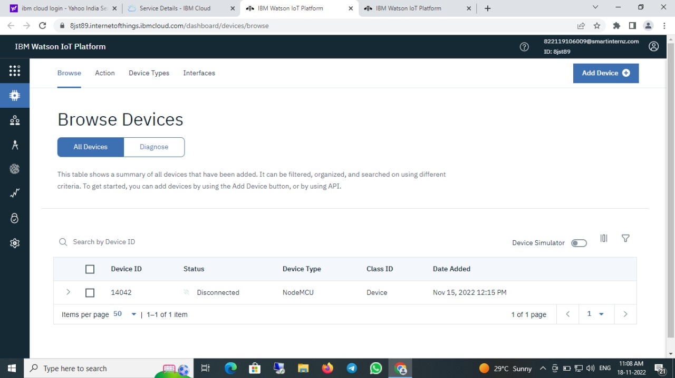
Step 6: click Board for risk and security overview card,it user for graphical representation boards

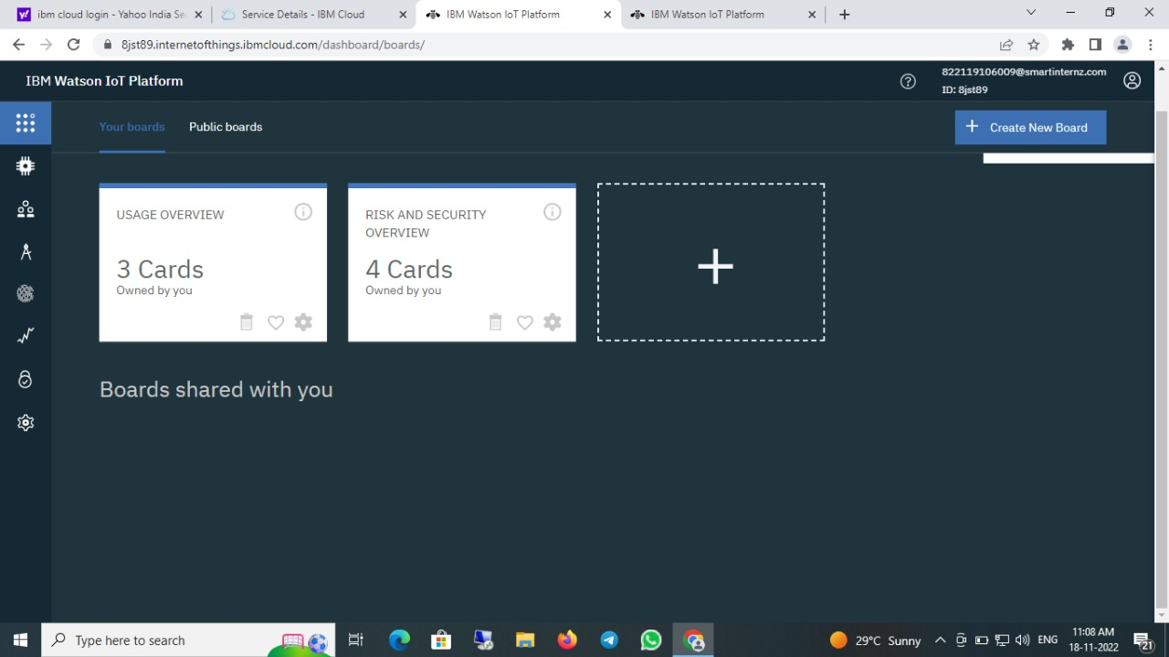
Step 7: create a device of node mcu

